HOUGHTON COUNTY LAND BANK AUTHORITY
REQUEST FOR PROPOSALS
BUILDING DEMOLITION SERVICES

August 31, 2022

Request for Proposal Index

1. Request for Proposal Description
2. Project Requirements
3. Proposal Requirements
4. Selection Process Overview and Selection Criteria
5. Proposal Due Date
6. Instructions to Bidders
7. Professional Insurance Requirements and Indemnification
8. Site Aerials & Photos
9. Asbestos Survey & Lead Paint Sampling Reports
10. Bid Sheet
11. Reference Sheet
HOUGHTON COUNTY LAND BANK AUTHORITY REQUEST FOR PROPOSALS
BUILDING DEMOLITION SERVICES

1. Project Description

The Houghton County Land Bank Authority (HCLBA) is requesting Competitive Sealed Proposals from qualified firms interested in contracting with the HCLBA to provide building demolition services for the removal, clean-up and where noted, partial stabilization of the following sites:

- 116 Osceola, Laurium – Complete demolition will include removal of the structure, along with any and all appurtenances and debris inside and outsides the structures and excavating and removing the concrete floor, foundation and footings. Contractor will address the change in grade between the sidewalk and basement floor level with sufficient fill to buttress the sidewalk which is higher. Site should be graded, seeded and mulched.
- 426 5th Street, Calumet – Complete demolition will include removal of the structure, along with any and all appurtenances and debris inside and outsides the structures and excavating and removing the concrete floor, foundation and footings. Site should be graded, seeded and mulched.
- 451 Pine Street, Calumet – Demolition of the north half of the building will include removal of the structure, along with any and all appurtenances and debris inside and outsides the structures and excavating and removing concrete floor (if any), foundation and footings. Stabilization will include framing and covering openings between structures remaining and structures removed, covering any exposed wall surfaces that require protection from the elements. Contractor will address the change in grade between the sidewalk and basement floor level with sufficient fill to buttress the sidewalk which is higher. Site should be graded, seeded and mulched.
- 501 Pine Street, Calumet – Complete demolition will include removal of the structure, along with any and all appurtenances and debris inside and outsides the structures and excavating and removing the concrete floor, foundation and footings. Site should be graded, seeded and mulched.
- 26364 Atlantic Street, Laurium – Complete demolition will include removal of the structure, along with any and all appurtenances and debris inside and outsides the structures and excavating and removing the concrete floor, foundation and footings. Site should be filled, seeded and mulched.
- 25608 D Street, Calumet – Complete demolition will include removal of the structure, along with any and all appurtenances and debris inside and outsides the structures and excavating and removing the concrete floor, foundation and footings. Site should be filled, seeded and mulched.
- 336 7th Street, Calumet – Work will entail removal of fire debris and demolition of foundations and floor. Site should be filled, seeded and mulched.
- 57435 and 57437 4th Street, Calumet - Complete demolition will include removal of the structure, along with any and all appurtenances (including a shed at the back of the lot) and debris inside and outsides the structures and excavating and removing the concrete floor, foundation and footings. Site should be filled, seeded and mulched.

The sites and buildings are illustrated on the aerial map and pictures attached to this document.

It is the HCLBA’s intent to select a contractor for the site that will, in the HCLBA’s sole determination, provide the best demolition proposal at the least cost.

2. Project Requirements:

Demolition – The contractor will be responsible for demolition, removal, and proper disposal of structures, concrete foundation, and contents of the existing vacant building listed above as well as all debris around the buildings including trees and brush adjacent to the structures. The contractor will be responsible for all costs of transport, proper disposal of all demolition debris including documentation of said disposal.

Certifications and permits – The contractor will be responsible for obtaining all certifications and permits necessary for completion of the project from the appropriate regulatory agencies. Copies of all certifications and permits including signed demolition waste manifests are to be provided to the HCLBA. The HCLBA will handle required zoning and historic district approvals in the Village of Calumet.

Houghton County Transfer Station – Houghton County will provide a special price of $80 per ton for handling non-asbestos containing debris for this project. However, they will only take 2-3 loads per day, Tuesday through Thursday and Friday by arrangement. The requisite paperwork and coordination with the Transfer Station will be required.

Utilities and Utility Disconnects – The contractor will be responsible for coordinating location and ensuring utility disconnects and providing documentation to the HCLBA that disconnections were made. Sewer and water leads should be marked on the surface after filling and grading.

Reuse of Materials – No materials from the project are proposed for reuse by the HCLBA.

Salvage of Materials – Contractor shall provide a description of what materials will be salvaged and how the balance will be disposed of. The contractor shall take ownership of all scrap/salvage materials and be permitted to recover and reuse the items as desired at the contractor’s risk. No debris may be taken off site for sorting.

Extent of Underground Demolition –The contractor shall remove foundations and any concrete floors, provide any needed fill, and grade area to level. Silt fence or other barriers to be used to prevent erosion of soils off site.

Responsibility for Temporary Facilities – The contractor will be responsible for all temporary facilities necessary to successfully complete the project – to include, but not limited to, portable restrooms, site fencing, site security, etc.

Special Requirements – Caution and care must be exercised to prevent damage to adjacent property, sidewalks, pedestrians, and streetscape and to ensure that existing businesses in the area can operate normally without significant disruption during demolition activities. All required street closures shall be approved at least 48 hours in advance of the commencement of work through the Villages of Calumet or Laurium. Contractor is responsible for coordinating or communicating with adjacent landowners as needed.

Safety- Provide information regarding firm’s safety record and describing the specific safety measures/plan to be used in this project to protect personnel, public, structures and infrastructure.

Price- The HCLBA will award a contract to the lowest responsive and responsible proposal. A lump sum price must include any and all fees related to the project requirements. Schedule of progress payments will be agreed upon at the time of contract award.

Timeline - Contractor should propose a timeline for completing the work. The project should be completed by November 15, 2023. The HCLBA anticipates having all funding in place by November with a portion from a legislated State Land Bank allocation for the County and the balance from County and Township funds.

Hazardous Materials – Contractor must dispose of demolition materials in accordance with all state and federal laws and take all steps required.

- 116 Osceola. A lead and asbestos survey was completed for the site and is attached. No asbestos was found. Lead appears to be less than the threshold amount.
- 426 5th Street. A full Phase I and Phase II environmental assessment was completed on the property in 2007 and is attached. A lead and asbestos survey was completed for the site and is attached. Lead and asbestos (pipe wrap) were found. Any containerized potential hazardous materials should be handled appropriately.
- 451 Pine Street. A lead and asbestos survey was completed for the site and is attached. A length of duct wrapped in asbestos was found in the basement of the north half of the building to demolished. Lead paint is present in the north half of the building.
- 501 Pine Street. A full Phase I and Phase II environmental assessment was completed on the property in 2017 and is attached. A lead and asbestos survey was recently completed for the interior of the still standing barn. Asbestos from the siding is present in the collapsed portion of the site and is now mixed in with the debris in the foundation. There is asbestos pipe wrap in the basement under the standing barn. Lead paint was found inside the first floor of the barn structure.
- 26364 Atlantic Street. A lead and asbestos survey was completed for the site and is attached. No asbestos was found. Lead paint was found.
- 25608 D Street. A lead and asbestos survey was completed for the site and is attached. Lead and asbestos (duct wrap and flooring) were found.
- 336 7th Street. Because the structure burned completely down, the debris should be treated as if it contains asbestos. A Phase I and II environmental assessment and lead and asbestos survey is scheduled but won’t have been completed at the time of this RFP.
- 57435 & 57437 4th Street. A lead and asbestos survey was completed for the site and is attached. No asbestos was found. Lead paint was found.

Expected Condition of Site at Completion of Demolition – It is expected that the contractor will fill as needed and grade each site to provide for positive surface drainage for the entire site. The contractor will be responsible for installation of silt fence to prevent sediment runoff, if necessary. The contractor will be responsible for repair of damage to any adjacent structures, and any curbing, sidewalk, or asphalt damaged during the project. Site should be graded, seeded and mulched.

3. Proposal Requirements:

Interested firms are encouraged to attend an optional pre-bid conference and walkthrough of the sites to be held Wednesday, September 14, 2022, at 2:00 p.m. starting at 426 5th Street in Calumet. If you would like to schedule a separate time for a walkthrough, please contact Jeff Ratcliffe at 906-482-6817 or jeff@kedabiz.com

Interested firms must, at a minimum, provide the following information by Friday, September 30, 2022, at 4:00 pm:

- Completed Bid Sheet (Attached). Include description of disposition of materials.
- Qualifications/Experience: Describe the firm’s qualifications and experience with this type of work. Give three (3) examples and reference contact information for previous similar projects. Use the attached form or include on company’s letterhead.
- Schedule: Provide a proposed project schedule to complete the scope of work described above.
- Firms are requested to submit one (1) copy of the proposal and limited to no more than five (5) pages.

4. Selection Process Overview and Selection Criteria

On or before the time specified herein, the respondents will submit a proposal in response to this RFP.

The HCLBA will award a contract to the lowest responsive and responsible bidder. A responsive bid is one that does not vary from the specifications and terms required. A responsible bidder is one whose reputation, past performance, experience, business and financial capabilities, and ability to complete performance within a specified time limit is such that he is judged capable of satisfying the contract. The HCLBA may reject any or all bids and waive minor irregularities in bids.

5. Sealed Proposal Due Date: Friday, September 30,2022, at 4:00 pm

Interested firms can mail or drop off proposals to:

HCLBA Demolition Project
c/o Houghton County Treasurer
401 E. Houghton Ave.
Houghton, MI 49931

The Houghton County Treasurer’s office is located on the first floor of the Houghton County Courthouse.

6. Instructions for Bidders

Proposals will only be accepted from responsible and responsive companies that have an established reputation.

No proposal may be withdrawn for a period of ninety (90) days after the proposal submission date.

DISPUTES: In cases of disputes as to whether or not an item or service quoted or delivered meets scope of work, the decision of the HCLBA shall be final and binding on all parties.

DEVIATIONS: Any deviations from the scope of work contained herein must be noted in detail on the respondent’s response for the HCLBA’s consideration.

CHANGES: Any changes in this request for proposal after the purchase order/contract agreement has been awarded must be with the written consent of the HCLBA; otherwise, the responsibility for such changes lies with the company. Any changes to the scope of work in this request for proposal package shall be in writing and an addendum will go out to all prospective respondents so each respondent can compete equitably.

QUESTIONS AND INQUIRIES: All questions and inquiries concerning this RFP must be directed to the HCLBA Project Manager Jeff Ratcliffe in writing and e-mailed to jeff@kedabiz.com.

7. Professional Insurance Requirements and Indemnification

The successful company shall procure and maintain insurance for protection from claims under workers' compensations acts; claims for damages because of bodily injury including personal injury, sickness or disease, or death of any and all employees or of any person other than such employees; claims for damages because of injury to or destruction of property, including loss of use resulting therefrom; claims caused by professional errors, acts, or omission; and any other insurance prescribed by law. The successful company shall name Houghton County and the Houghton County Land Bank Authority, Charter Township of Calumet, Village of Calumet, Village of Laurium, their elected and appointed officials, officers, and employees, and the Keweenaw Economic Development Alliance as “Additional Insured” as their interests may appear but only with respect to services performed or provided by successful company on behalf of the HCLBA under Contractor’s commercial general liability insurance policy. The successful company shall, within 10 days of the full execution of any contract resulting from this RFP, provide the HCLBA with a certificate(s) of insurance evidencing the coverage’s required above and containing an endorsement to the effect that any cancellation or non-renewal shall not be until 10 days after the insurer, or the selected company gives written notice to the HCLBA.

Without limiting the provisions of paragraph above, the selected company shall during the term of any contract resulting from this purchase and maintain insurance with limits not less than those set forth below:

The successful company shall take out and maintain, during the life of the contract agreement, workers’ compensation and employer’s liability insurance for all employees to be engaged in services on this project under this agreement in an amount not less than $1,000,000.00, and in case any such services are sublet, the company shall require all subcontractor(s) also to provide workers’ compensation and employer’s liability insurance in an amount not less than $1,000,000.00 for all of the subcontractor’s employees to be engaged in such.

Employer’s Liability Insurance -$1,000,000 each accident, $1,000,000 disease policy limit, $1,000,000 disease each employee Commercial General Liability Insurance -$1,000,000 per occurrence (bodily injury and property damage) / $1,000,000 general aggregate Automobile Liability Insurance -$1,000,000 combined single limit (bodily injury and property damage), each accident Professional Services: The selected company shall indemnify and hold the HCLBA, Houghton County, its elected and appointed officials, officers, and employees and Keweenaw Economic Development Alliance, harmless from and against judgments, liabilities, damages, losses, costs, and expenses (including, but not limited to, reasonable attorneys' fees and costs but only to the extent otherwise authorized by law) to the extent caused by any negligent act, error, or omission in the performance and furnishing of the selected company’s professional services under any contract resulting from this RFP, including any negligent act, error or omission of any individual or entity directly or indirectly employed by the selected company to perform any of the work or anyone for whose acts, errors, or omissions the selected company may be liable, regardless of whether or not caused in part by a party indemnified hereunder.

Other Than Professional Services: With respect to all acts or omissions of the selected company, or any individual or entity directly or indirectly employed by the selected company to perform any of the work or anyone for whose acts, errors, or omissions the selected company may be liable, which do not arise out of or result from the performance of professional services, and which may be covered by employer’s liability insurance, commercial general liability insurance, automobile liability insurance, or other general liability insurance, the selected company shall indemnify and hold the HCLBA , Houghton County, and Keweenaw Economic Development Alliance, harmless from and against judgments, liabilities, damages, losses, costs, and expenses (including, but not limited to, reasonable attorneys' fees and costs but only to the extent otherwise authorized by law) to the extent caused by or arising out of the selected company’s negligent acts of commission or omission (or those of or any individual or entity directly or indirectly employed by the selected company to perform any of the work or anyone for whose actions or failure to act the selected company may be liable) during the performance of this Agreement.

The selected company shall require any subconsultants and subcontractors to purchase and maintain insurance with limits not less than those required above to be purchased and maintained by the selected company. In addition, the selected company shall require any subconsultants and subcontractors to assume the selected company’s indemnification obligations under any contract resulting from this RFP to the extent they relate to the subconsultant’s or subcontractor’s obligations under any contract with the selected company.

Houghton County is an equal opportunity employer and does not discriminate on the basis of race, color, national origin, age, disability, religion, sex, or family status
8. Site Aerials and Photos

Calumet Sites
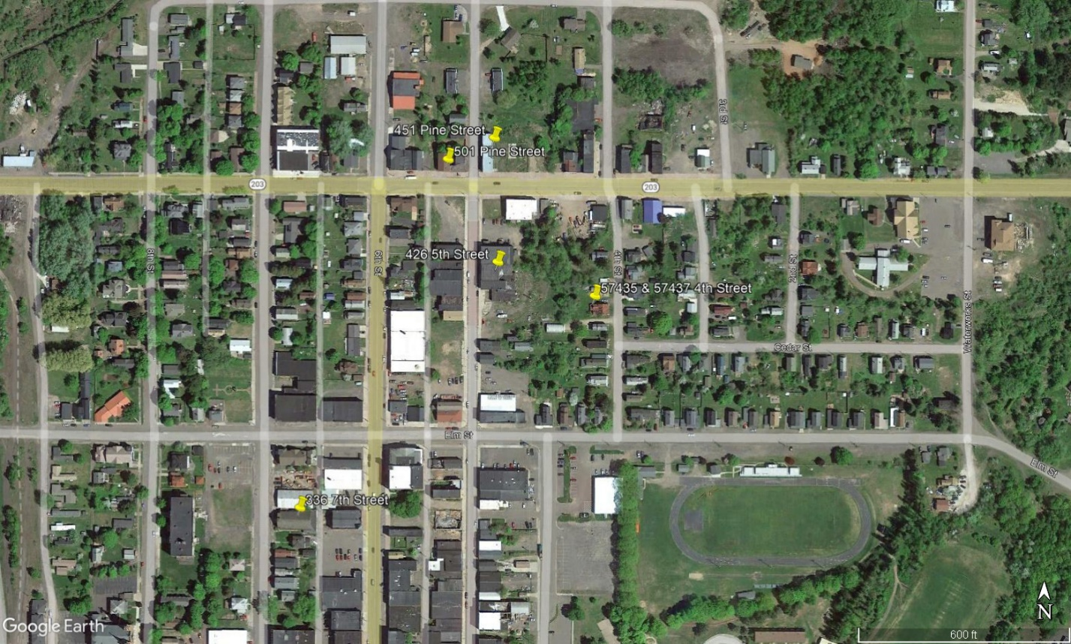

Laurium Sites
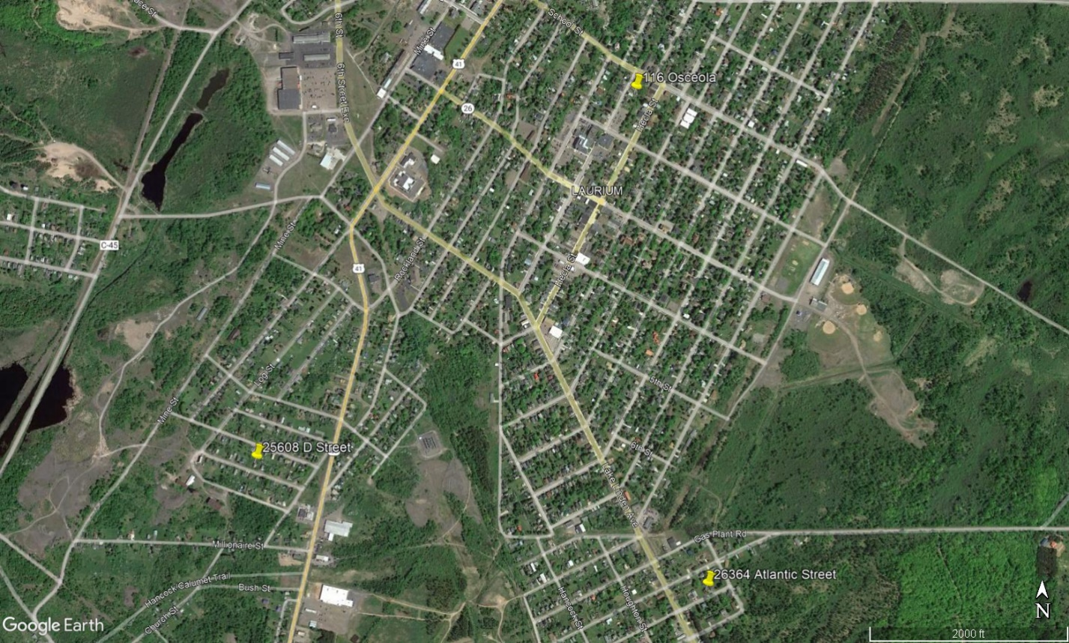
A. 116 Osceola Site Aerial & Photos

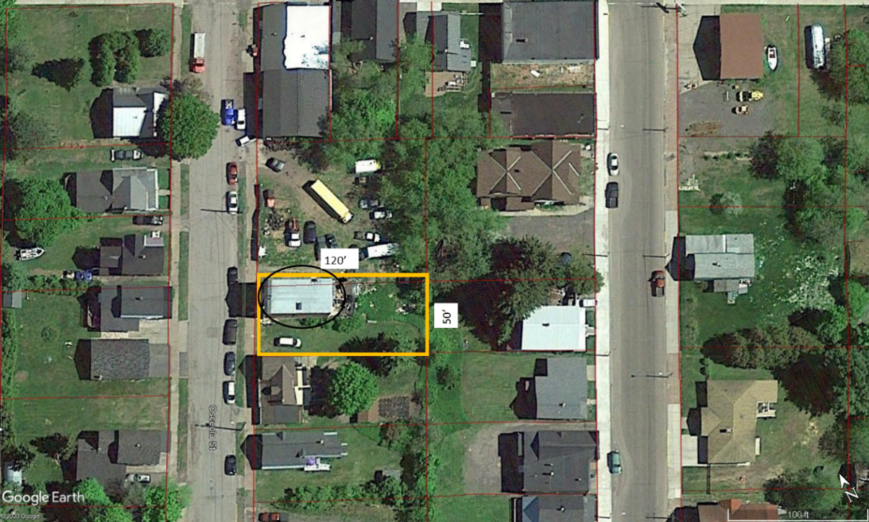
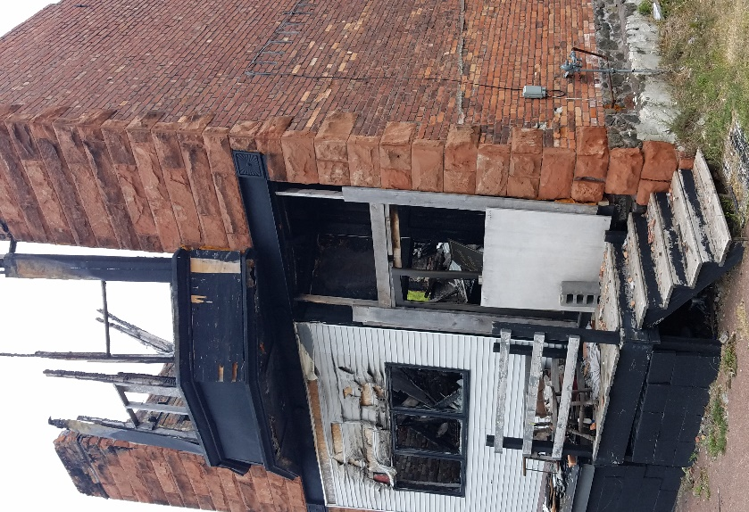
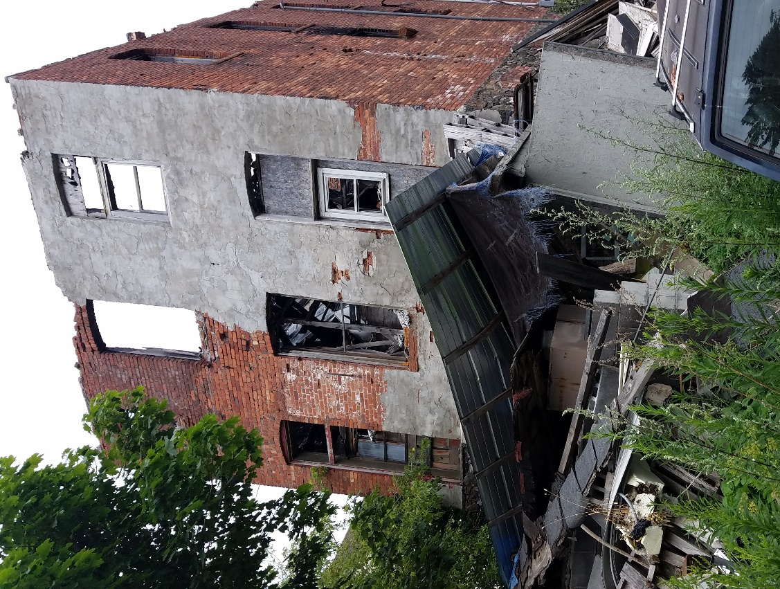
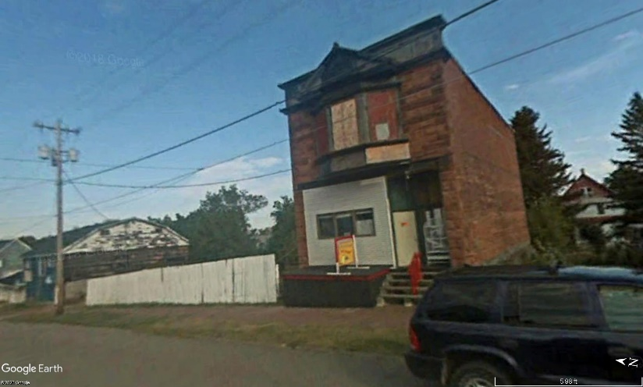
Bottom Left. View looking southeast at the front of the building. Bottom Right. View looking southwest at the back of the building.
Google Street View 9/2008 pre-fire. View looking east.
Left. View looking southeast at the front of the building. Above. View looking southwest at the northeast side.
B. 426 5th Street Site Aerial & Photos

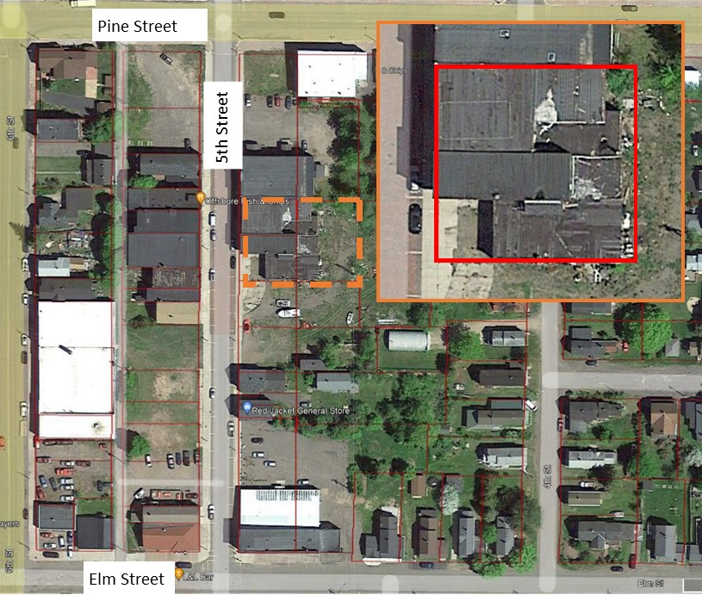

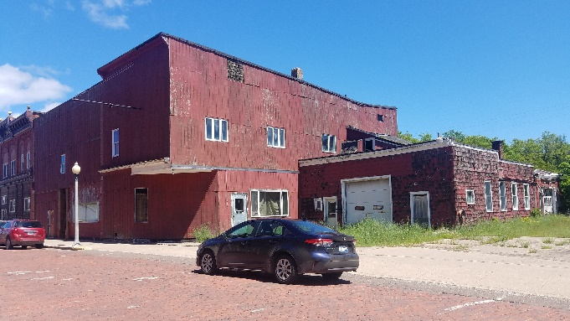

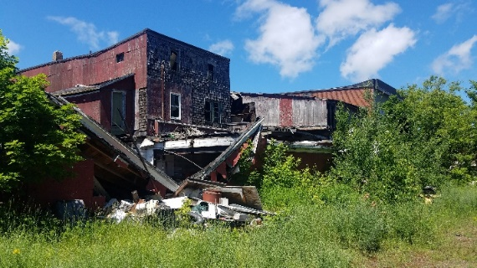
C. 451 Pine Street Site Aerial & Photos

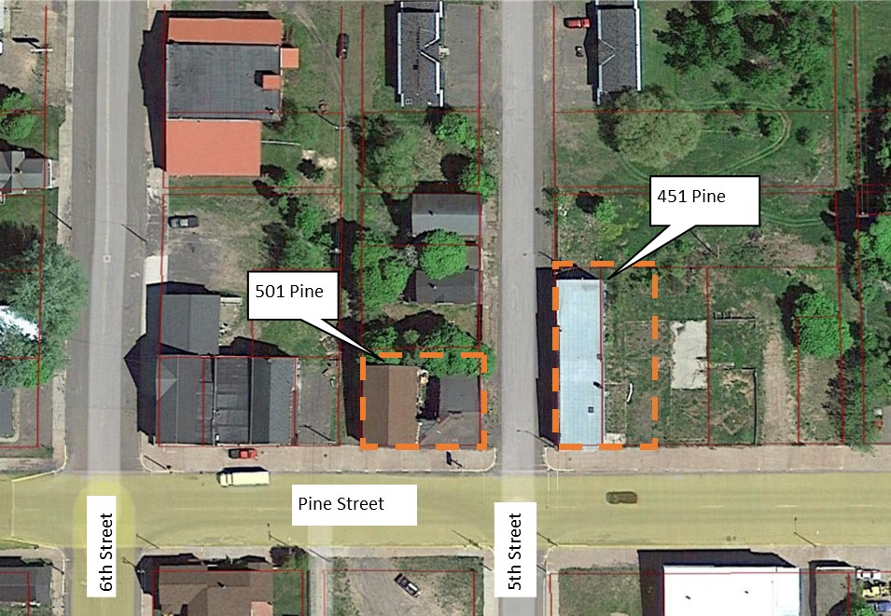

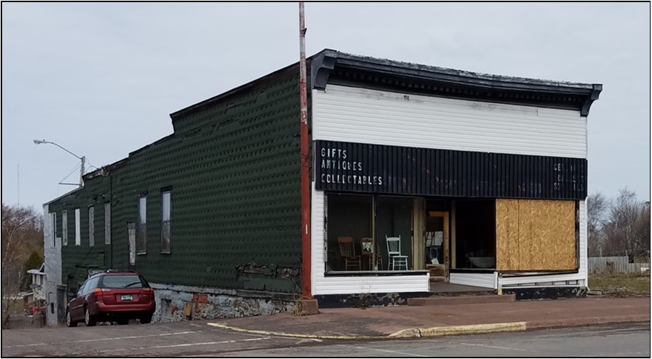

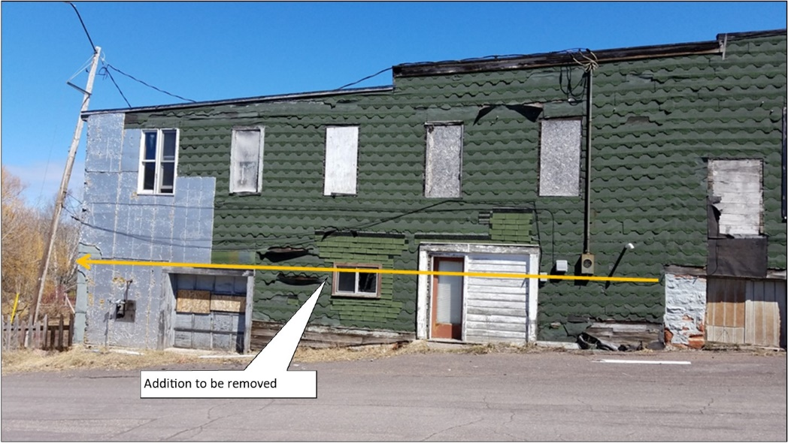
D. 501 Pine Street Site Aerial & Photos

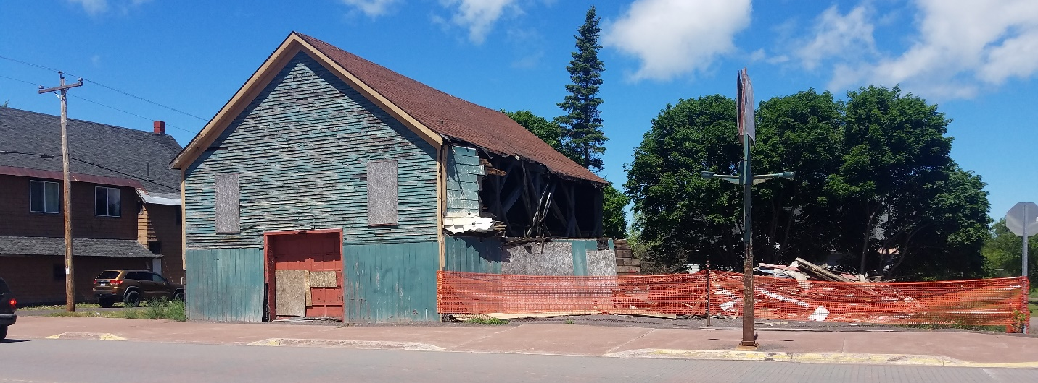

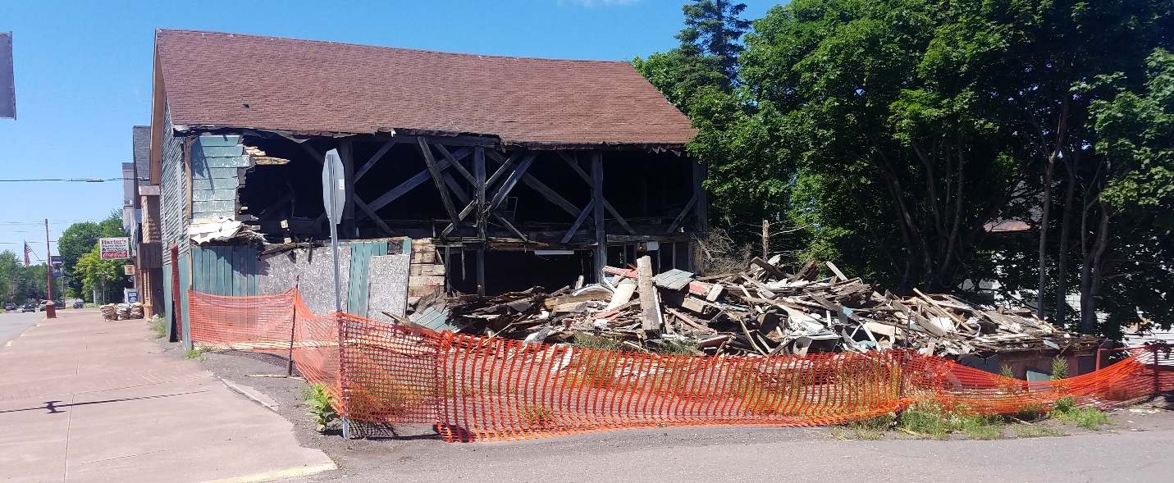
E. 26364 Atlantic Street Site Aerial & Photos

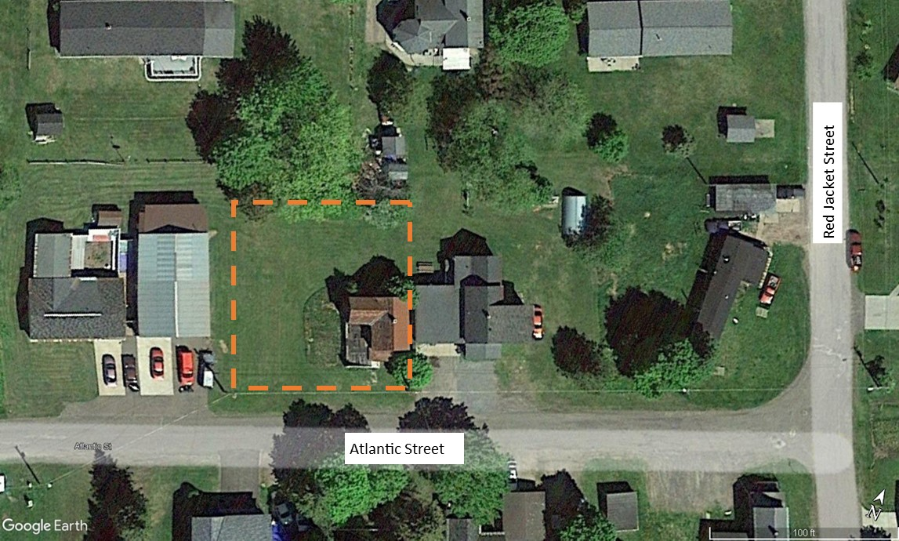

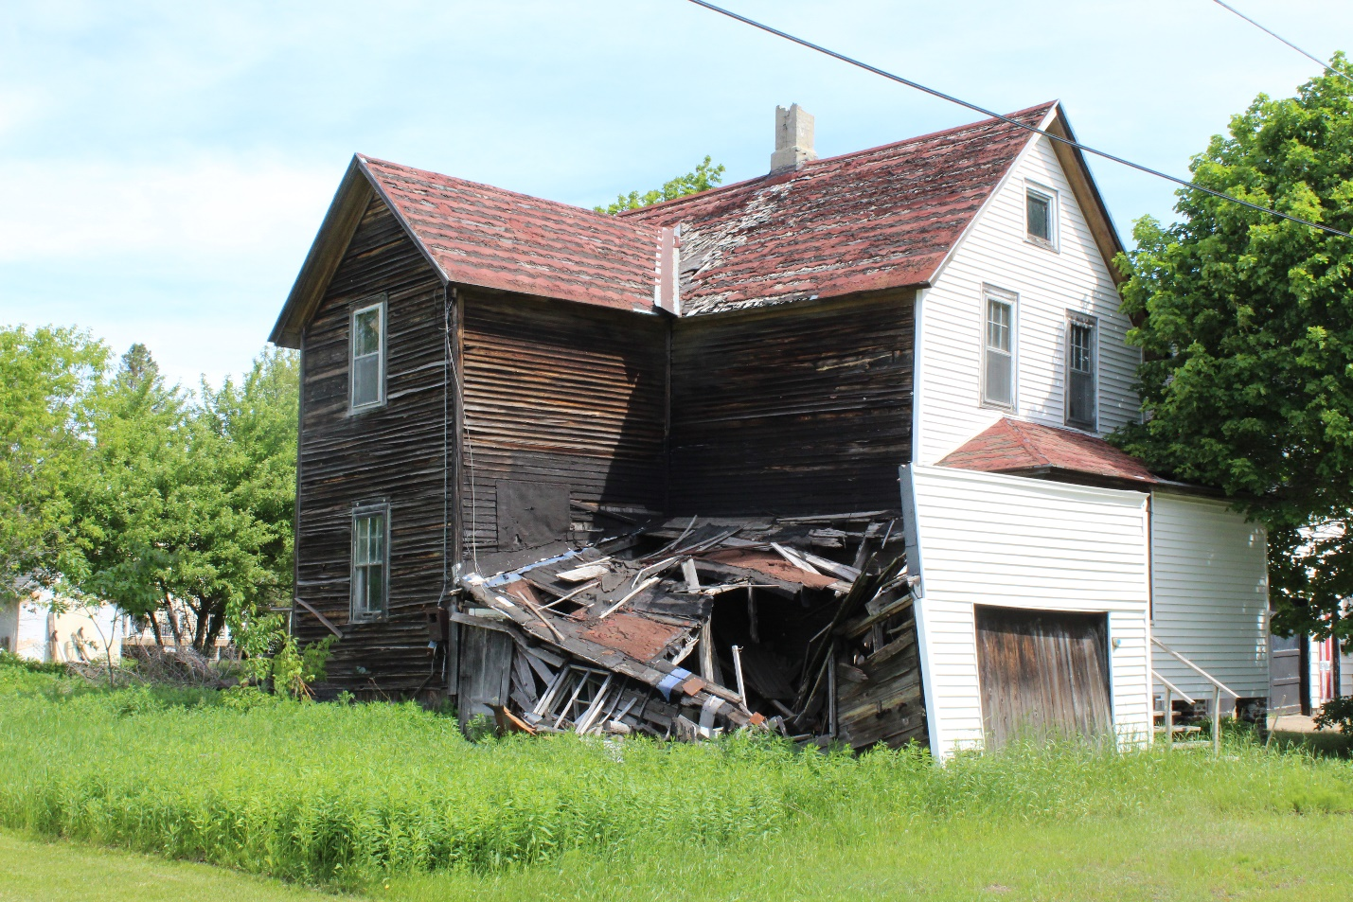
F. 25608 D Street Site Aerial & Photos

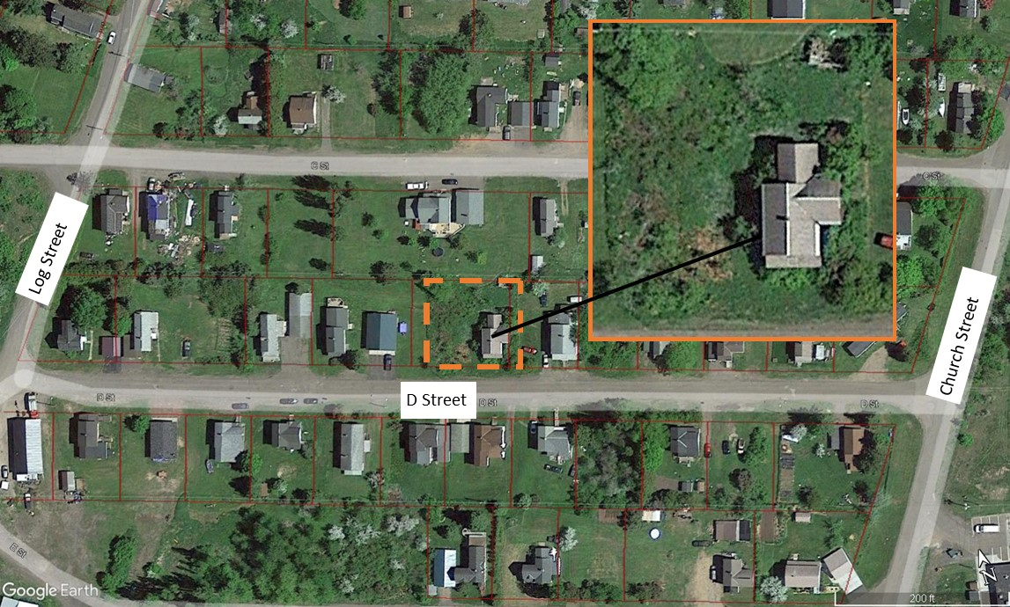

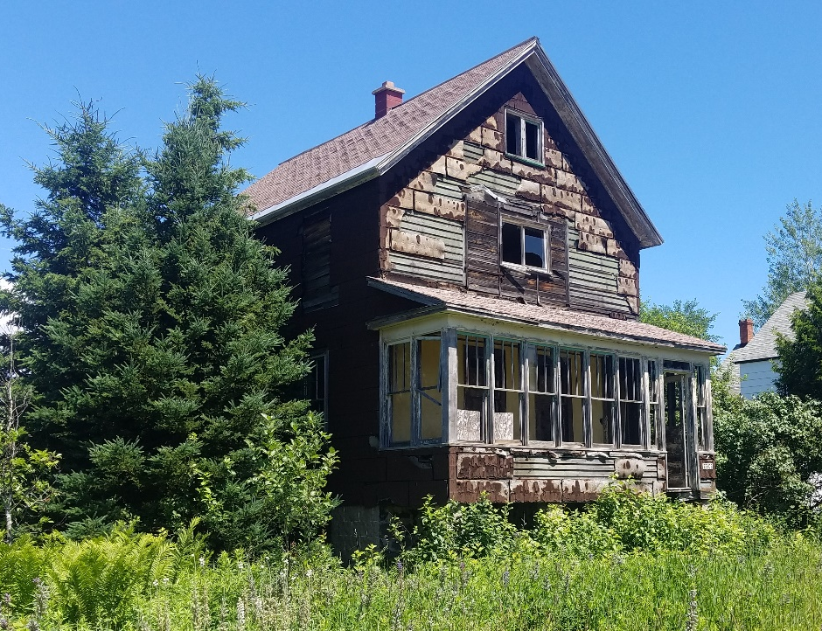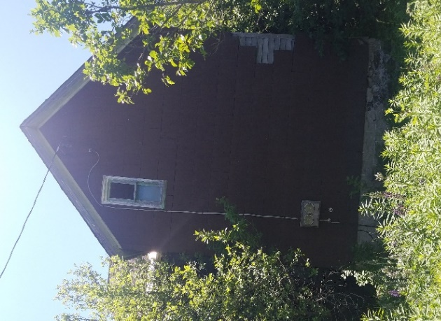

G. 336 7th Street Site Aerial & Photos

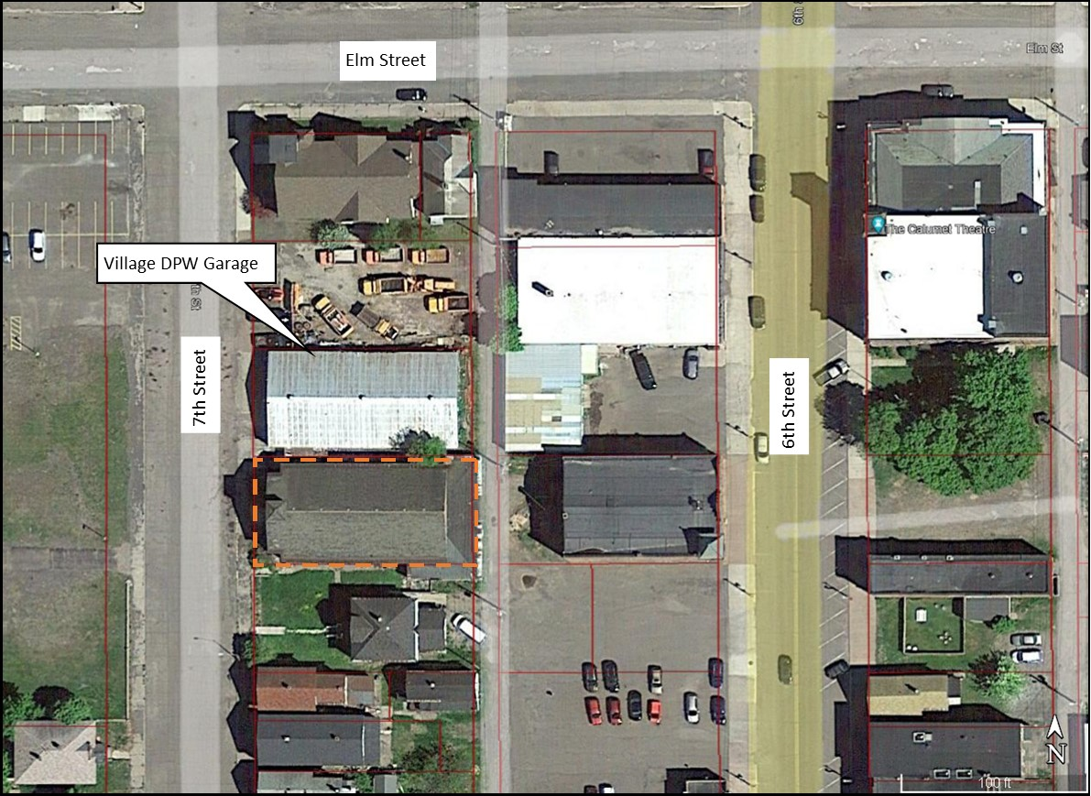
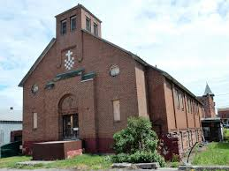 Left. Church before fire. Below. Debris to be removed
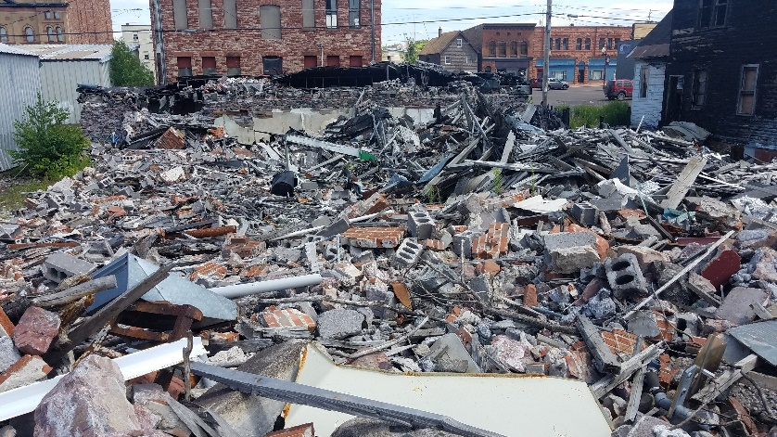
H. 57435 & 57437 4th Street Site Aerial & Photos

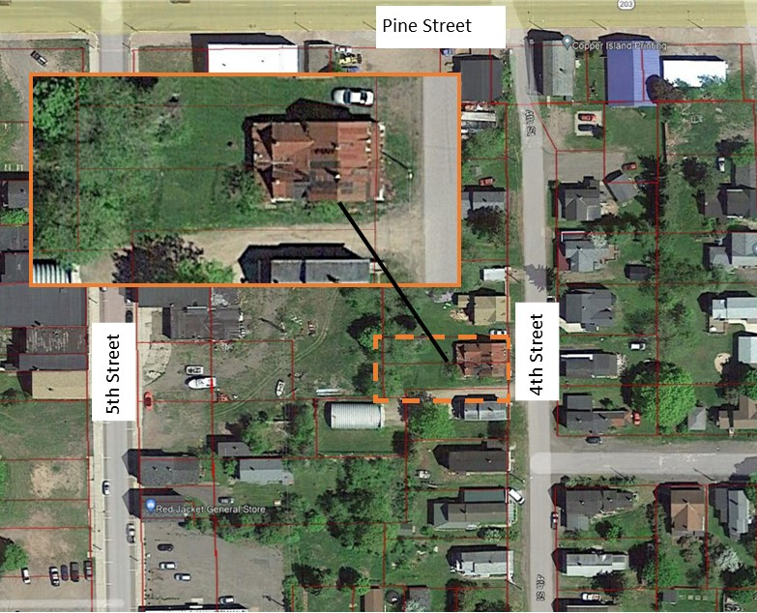

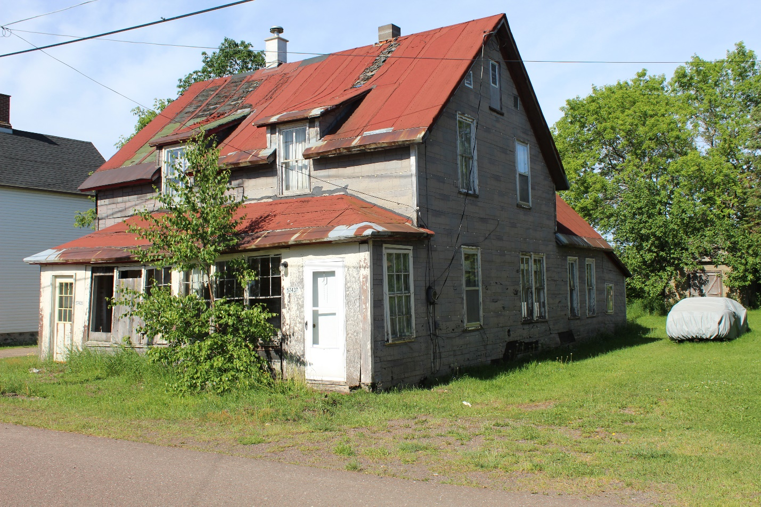

9. Asbestos Survey & Lead Containing Paint Sampling Reports and Environmental Assessment Reports

Reports will be provided in a separate document.

10. BID SHEET

Request for Demolition and Removal Bid

Demolition and Disposal of Building, Debris and Floor/Foundation/Footings; Grading; etc.

- 116 Osceola, Laurium $___________________________________

- 426 5th Street, Calumet $___________________________________

- 451 Pine Street, Calumet $___________________________________

- 501 Pine Street, Calumet $___________________________________

- 26364 Atlantic Street, Laurium $___________________________________

- 25608 D Street, Calumet $___________________________________

- 336 7th Street, Calumet $___________________________________

- 57435 & 57437 4th Street, Calumet $___________________________________

Other (Specify): $___________________________________

Total Bid Price: $___________________________________

Proposed Completion Date: ______________________________________________________

Materials to be disposed of at landfill/transfer station: __________________________________

Materials to be disposed of as inert fill: ______________________________________________

Materials to be salvaged: _________________________________________________________

Name of Company: _____________________________________________________________

Address: ______________________________________________________________________

______________________________________________________________________________

Date: ______________________________ Phone No.: ________________________________

Email: ________________________________________________________________________

Authorized Contact Person: _______________________________________________________

I certify that the amount and nature of the services to be furnished is understood and that the nature of this bid is in strict accordance with the conditions set forth and is a part of this bid, and that there will at no time be a misunderstanding as to the intent of the specifications or conditions to be overcome or pleaded after the bids are opened. My price reflects meeting all project requirements outlined in the Request for Proposal.

I further certify that this bid is made without prior understanding, agreement or connection with any corporation, firm or person submitting a bid for the same materials, supplies, equipment or service, that it meets or exceeds all specifications contained herein, and is in all respects fair and without collusion or fraud. I understand collusive bidding is a violation of state and federal law and can result in fines, prison sentence, and civil damage awards. I agree to abide by all conditions of this bid, all specifications as stated and certify that I am authorized to sign for the bidder.

Authorized Signature: ____________________________________________________________

Print Name & Title: ____________________________________________________________

11. Three References for Similar Projects

Reference #1
Company/Municipality: ________________________________________________________

Contact Person: ______________________________ Title:___________________________

Address: _____________________________ City: ___________________ State: ________

Phone Number: _____________________________ Email: __________________________

Project Timeline: __________________________ Project Budget: _____________________

Type of Project: ______________________________________________________________

Reference #2
Company/Municipality: ________________________________________________________

Contact Person: ______________________________ Title:___________________________

Address: _____________________________ City: ___________________ State: ________

Phone Number: _____________________________ Email: __________________________

Project Timeline: __________________________ Project Budget: _____________________

Type of Project: ______________________________________________________________

Reference #3
Company/Municipality: ________________________________________________________

Contact Person: ______________________________ Title:___________________________

Address: _____________________________ City: ___________________ State: ________

Phone Number: _____________________________ Email: __________________________

Project Timeline: __________________________ Project Budget: _____________________

Type of Project: ______________________________________________________________

