City of Escanaba Wastewater Department Ludington Lift Station Generator

TO BIDDERS: 12/21/2021

RFP OPENING: 01/18/2022 @ 2:00 p.m. EST

ADVERTISED: 12/23/2021

INVITATIONS TO
BID SENT TO: FOUR (4)

Wolverine Power Systems
308 N. State Hwy. M553
Marquette, MI 49855

Total Energy Systems
2211 American Blvd.
De Pere, WI 54115

Cummins NPower, LLC
875 Lawrence Dr.
De Pere, WI 54115

Xylem
Attn: Bob Williams
11850 Sears St.
Livonia, MI 48150

INDEX TO CONTRACT DOCUMENTS

Notice to Bidders

Specifications

    - Specifications
    - General information
    - Minimal Proposal Requirements
    - Inspection
    - Payment
    - Method of Award
    - Basis of Award
    - Warranty
    - Other Requirements
    - Project Coordinator

Bidders Proposal

Bid Bond

NOTICE TO BIDDERS

Sealed bids will be received by the City of Escanaba at the office of the City Clerk, on or before 2:00 p.m. EST, on: Tuesday, 1/18/2022.

The bids will be publicly opened and read in Room 101 in the City Hall located at 410 Ludington Street, Escanaba, Michigan at said date and time.

Bidder’s proposals, and/or specifications may be obtained from the office of the City Clerk, located at 410 Ludington Street, Escanaba, Michigan, 49829. No bids will be considered unless the proposal form and /or specifications (furnished by the City of Escanaba, Michigan), are properly completed and enclosed in a sealed envelope, marked:

City of Escanaba Wastewater Department Ludington Lift Station Generator
In addition, the City of Escanaba, Michigan will not consider any proposal which has not been received prior to the published time, date, and year of bid opening. (FAX transmittals will not be accepted.)

A Certified Check, Cashier’s Check, or Bidder’s Bond, drawn payable, without condition, to the City of Escanaba, Michigan, in an amount not less than 10% of the bid, will be submitted with each proposal as a guarantee that if the bid is accepted, the bidder will furnish materials or services as stated in his or her proposal. On failure of the successful bidder to fulfill the conditions of his or her proposal, he or she shall forfeit said deposit to the City of Escanaba, Michigan as liquidated damages. The acceptance of the proposal will be contingent upon the bidder’s acceptance of this provision.

The City of Escanaba, Michigan reserves the right to reject any or all bids, or any part thereof at its discretion, and to waive any irregularities in the bidding. The City of Escanaba, Michigan may also split bids at its discretion. The City further reserves the right to negotiate directly with any and all bidders concerning any matter related to any bid.

All City of Escanaba, Michigan bids are prepared to afford all vendors the equal opportunity for fair and equitable competition. The City of Escanaba, Michigan assumes no liability or responsibility for any errors or oversights in the preparation and/or publication of bids.

Michael Humbert
Project Manager
City of Escanaba

City of Escanaba Wastewater Department Ludington Lift Station Generator

Specifications:

See check list in minimal requirements for specifications.

General Information:

The City of Escanaba Wastewater Department is seeking proposals for the purchase of a new un-used stationary natural gas generator, automatic transfer switch and a manual throw switch. The intended use of this generator will be providing back-up power during power loss events and other emergencies. It also provides us an upgrade at our lift station. The location in which we will be upgrading is our Ludington Lift Station. The automatic transfer switch will preferably be manufactured by the same manufacturer as the generator so they are compatible. The manual throw switch will allow us to use an external source of power if needed. The new un-used generator will replace an existing Cummins Onan 100, Onan Transfer Switch (See information and pictures below).
The Ludington Lift Station has an existing stationary natural gas generator currently which is a Cummins Onan 100. The Lift Station currently has a 200 amp, 480 volts and a 3-wired delta service. There are no current plans to upgrade any pumps, so electrical demands will remain the same. Based off our electric meter read history, the peak amp draw is around 20 amps for the past five (5) years. The following specifications outline the requirements for a successful proposal.

ALL PROPOSALS WILL BE GIVEN CONSIDERATION BASED OFF OF SEVERAL FACTORS, WHICH INCLUDE THE FOLLOWING POINTS OF INTEREST:
- Engine Type and Size
- Pricing
- Warranty
- Continuous Stand-by Power Rating and Fuel Consumption

Please Note, we have high expectations for this generator and all components asked for in this RFP. We expect this generator to function without supervision. The ability to recognize power failures and or phase loss is a critical component. Starting up and shutting off automatically is also a key function.
Current Generator Information:
Generator And Automatic Transfer Switch Specifications:
All Generator specs are to meet the existing generator rating or exceed.
- Generator Onan 100 generator (Model No. 100ENTXL27907B, Serial No. K900357087)
  - Volts- 480
  - 3 Phase
  - Amps-150
- Onan Switch Gear (Model No. OTCU 225G 160G, Serial No. J900354967)
  - Volts- 277/480
  - 3 Phase
  - Amps- 225
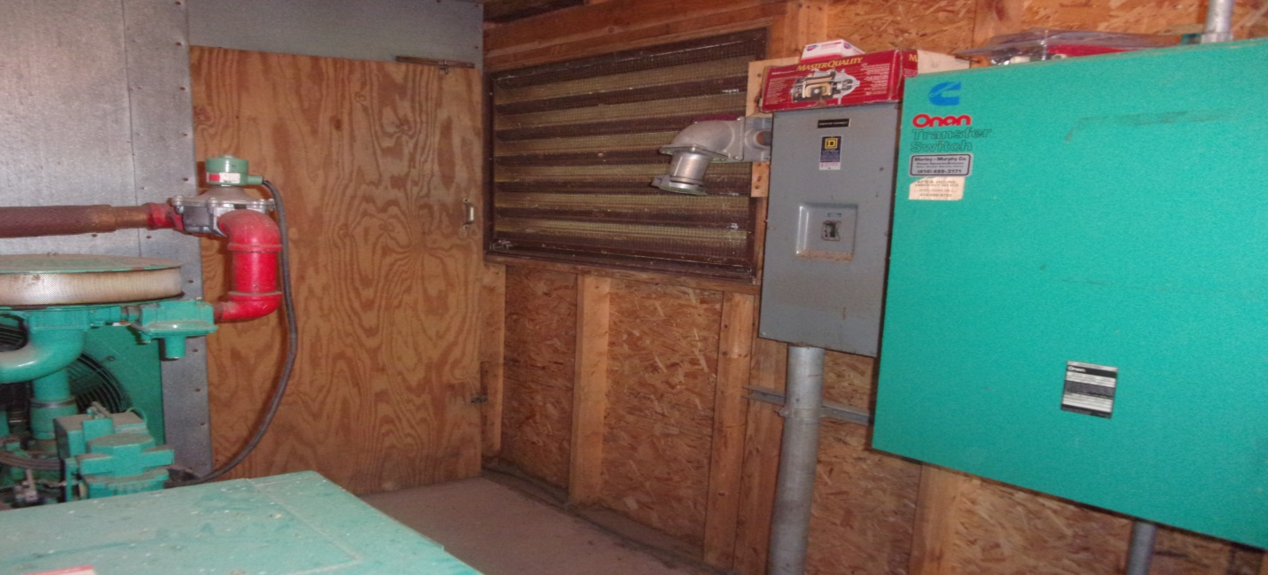

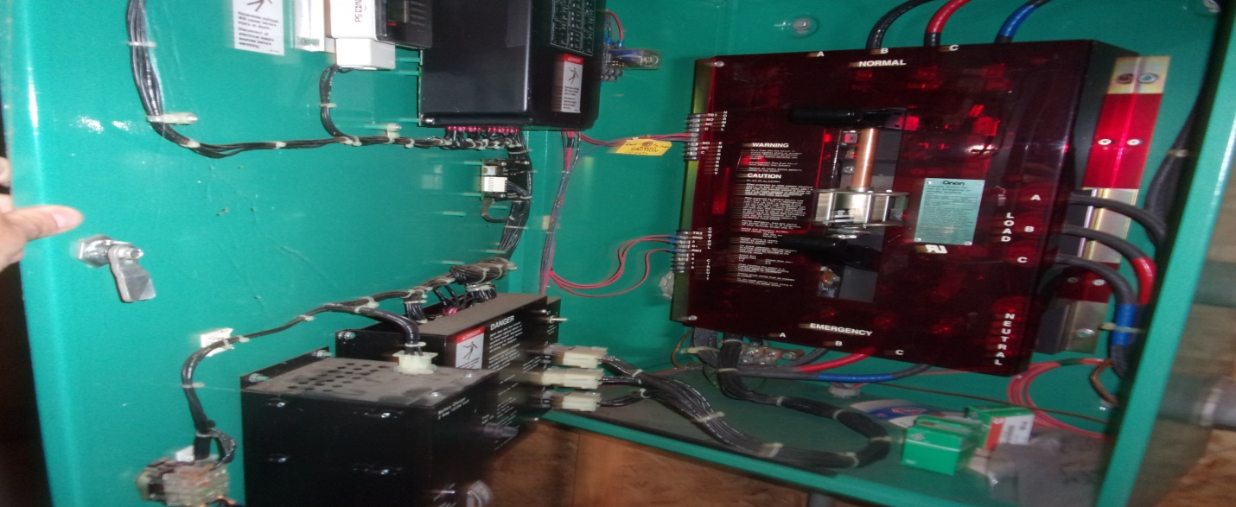

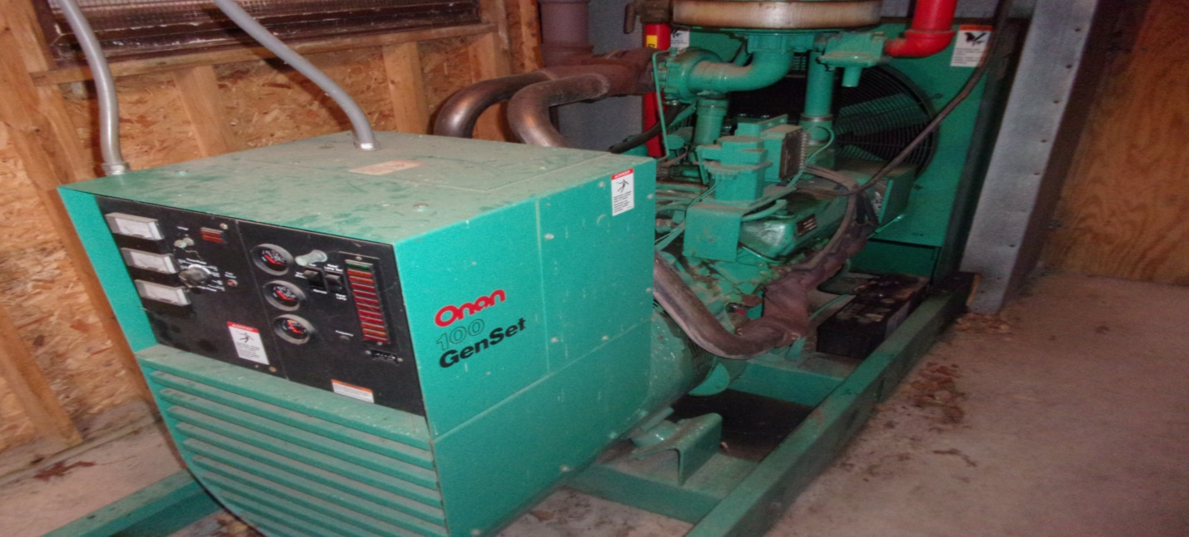

City of Escanaba Wastewater Department Ludington Lift Station Generator
Minimal Proposal Requirements
Please check each item that is achievable in your proposal and provide written explanation if you are not able to fulfil any requirements

Please return this page with RFP
Generator set & Automatic Transfer Switch
- ______________ Furnish one (1) Generator that meets or exceeds current generator rating of at least one hundred (100) K.W. (Replacing an existing Onan 100 Stationary Generator)
- _____________________________________ Brand of Generator
- _____________________________________ Generator Model Number
- _______________ Provide K.W. rating for Generator
- _______________ Generator powered by natural gas
  - ____________ Number of Btu’s required for natural gas generator
- _______________ Furnish one (1) Automatic Transfer Switch and all other components needed to have generator set work automatically during emergencies/power failure
- ______________________________________ Brand of Automatic Transfer Switch
- ______________________________________ Automatic Transfer Switch Model Number
- _______________ Furnish Manual Transfer
- ______________________________________ Brand of Manual Transfer Switch
- ______________________________________ Manual Transfer Switch Model Number
- _______________ Please provide pictures, specifications, overview, and any other pertinent information
- _______________ Provide three (3) copies of the Operations and Maintenance Manuals for generator, Automatic Transfer Switch, and other electrical components provided
- _______________ Provide onsite startup and commissioning of the new upgraded system
- _______________ Provide operator and maintenance training onsite for the new upgraded system once it is installed
- _______________ All equipment must be in accordance with all Federal, State, City, and Department rules, regulations, and policies
- _______________ Provide warranty on all equipment installed for a minimum of one year
PLEASE COMPLETE AND RETURN THE MINIMUM SPECIFICATIONS FORM SUPPLIED

Please Provide Any Additional Information Required

Escanaba Wastewater Plant
1900 Willow Ck Road
Escanaba, MI 49829

This space intentional left blank

INSPECTION

Owner reserves the right to inspect Contractor’s work at any phase of the operation. Contractor must provide any and all reports received from any inspections that may be completed as per the confines of this project. Owner reserves the right to require the Contractor to coordinate various phases so as to facilitate the inspection process. If the Owner determines that any of the Contractor’s work is unsatisfactory, the Contractor shall correct the work at his own expense.

PAYMENT

Shall be 80 percent upon delivery and 20 percent following startup with owner’s acceptance.

Method of Award

The City of Escanaba, Michigan, reserves the right to reject any or all bids, or any part thereof at its discretion, and to waive any irregularities in the bidding. The City of Escanaba, Michigan, may also split bids at its discretion. The City further reserves the right to negotiate directly with any and all bidders concerning any matter related to any bid.

Basis of Award

All proposals will be reviewed based on qualifications, price, completion time frame previous experience and the best interest of the City of Escanaba. The City of Escanaba reserves the right to accept or reject any proposals.

Sealed proposals will be received by the City of Escanaba at the office of the City Clerk on or if any alternatives are proposed, please spell out clearly the benefits of alternatives proposed.

WARRANTY

The Contractor guarantees workmanship and materials for a minimum of one (1) year from the date of acceptance.

OTHER REQUIREMENTS

The successful bidder will be required to provide the following items within 20 days following the City Council’s approval of the bid award.

Not Applicable

PROJECT COORDINATOR
Michael Humbert
Water- Wastewater Department
410 Ludington Street
PO Box 948
Escanaba, MI 49829
mhumbert@escnanba.org
Telephone: (906) 786-1301

BIDDER’S PROPOSAL

City of Escanaba Wastewater Department Ludington Lift Station Generator - 2021

DATE:_______________________________

City of Escanaba
Escanaba, Michigan 49829

We, the undersigned, agree to furnish the City of Escanaba, Michigan ALL MATERIALS WITH REGARD TO THE LUDINGTON LIFT STATION GENERATOR in accordance with the attached minimum specifications, which are part of this proposal, at the following price:

BID: Bid amount to furnish Generator and
all components specified: $_________________________

CERTIFIED CHECK, CASHIER’S CHECK OR
BIDDER’S BOND ENCLOSED IN THE
AMOUNT OF: (Not less the 10% of total) $__________________________ (must be included to qualify)

Please include the following items with the bid:
- Completed -- Minimal Proposal Requirements Check List
- Certified Check, Cashier’s Check or Bid Bond
- Factory Specification sheet of proposed generator

SUBMITTED BY:
FIRM:_________________________________________
ADDRESS:_____________________________________
BY:___________________________________________
PRINTED:_____________________________________
TITLE:________________________________________
PHONE:_____________________ FAX:_____________
BID BOND

City of Escanaba Wastewater Department Ludington Lift Station Generator - 2021

KNOWN TO ALL MEN BY THESE PRESENT, that we, the undersigned, as principal and ____________________________________________________________________,
as Surety, are hereby held and firmly bound unto the City of Escanaba, Delta County, Michigan, as Owner in the penal sum of __________________________________________ for the payment of which, well and truly to be made, we hereby jointly and severally bind ourselves, our heirs, executors, administrators, successors and assigns.

Signed, this __________________ day of ________________________________, 2021.

The condition of the above obligation is such that whereas the Principal has submitted to the Owner a certain Bid, attached hereto and hereby made a part hereof to enter into a contract in writing, for

_______________________________________________________________________________

_______________________________________________________________________________

NOW, THEREFORE,
(a) If said Bid shall be rejected, or in the alternate.
(b) If said Bid shall be accepted and the Principal shall execute and deliver a contract in the form of Contract attached hereto (properly completed in accordance with said Bid) and shall furnish a bond for his faithful performance of said contract, and for the payment of all persons performing labor or furnishing materials in connection therewith and shall in all other respects perform the agreements created by the acceptance of said Bid.

Then this obligation shall be void, otherwise the same shall remain in force and effect; it being expressly understood and agreed that the liability of the Surety for any and all claims hereunder shall, in no event exceed the penal amount of this obligation as herein stated.

The Surety, for value received, hereby stipulates and agrees that the obligations of said Surety and its bond shall be in no way impaired or affected by any extension of the time within which the Owner may accept such Bid; and Surety does hereby waive notice of any such extension.

IN WITNESS THEREOF, the Principal and Surety have hereunto set their hands and seals, and such of them are corporations who have caused their corporate seals to be hereto affixed and these presents to be signed by their proper officers, the day and year first set forth above.

SEAL:

_______________________________(L.S.)

Principal

Surety

