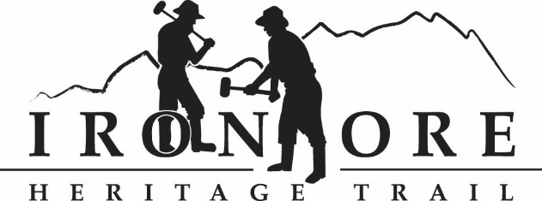
102 W. Washington Street, #232
Marquette, MI 49855
906-235-2923
Ironoreheritage@gmail.com

ADVERTISEMENT FOR BIDS

The Iron Ore Heritage Trail Recreation Authority is seeking bids for a repair on the paved section of the Iron Ore Heritage Trail that includes the following items of work:

- Removal of a 20’ x 10’ area of HMA, excavation for and installation of a 30ft long - 12” HDPE culvert (alternate material to be approved by the engineer) with class II backfill, 6” aggregate base and the corresponding 3” thick HMA patch near the Jackson Pit mine in Negaunee MI. Location is approximately 3600 feet west along the trail from the new pavilion in Jackson Mine Park. All excavated materials will be disposed of off-site. Disturbed areas shall be topsoiled and seeded to prevent erosion.

This is a LUMP SUM project and bids shall include all necessary labor, materials, and equipment to perform the above items of work.

An individually scheduled pre-bid meeting on-site is available and if requested, shall take place no less than seven days from the bid due date. To schedule, contact Ben Banfield of Coleman Engineering Company at 906-235-3767 or via email at bbanfield@coleman-engineeing.com

Bids must be received by 12:00 p.m. EDT (local time) on Friday, May 7, 2021 via email to Carol Fulsher, Administrator, Iron Ore Heritage Trail Recreation Authority at ironoreheritage@gmail.com or deliver to 102 W. Washington Street, #232, Marquette MI 49855. The Recreation Authority reserves the right to reject any and all bids for any reason.

No bid security shall be required for this project but insurance will be required for the successful bidder.

Prevailing wage rates will not be required for this project.

Bid Sheet

Name of Bidder: ___________________________________________

Lump Sum Bid:_____________________________________________

Project Start Date and Days to Complete:________________________

Signature:__________________________________________________

